

**THE STATE UNIVERSITY OF ZANZIBAR**

**SCHOOL OF SOCIAL AND NATURAL SCIENCE**

**DEPARTMENT OF SOCIAL SCIENCE**

**TUNGUU CAMPUS**

**COURSECODE: INF 2105**

**COURSETITLE: SOFTWARE APP**

**DEVELOPMENT**

**DATE: 3/11/2021**

**SUPERVISER: Mr. MASSOUD**

**STUDENT NAME: OMAR SALUM KHAMIS**

**REG NO: BITAM/8/20/035/TZ**

How to install JAVA JDK in computer

Jdk allow the programmer to code and to run Java programs in computer.

The following are the step by step on how to install Java jdk in computer.

1. First step is to double click in jdk file in order to allow the installation of Java file in computer.

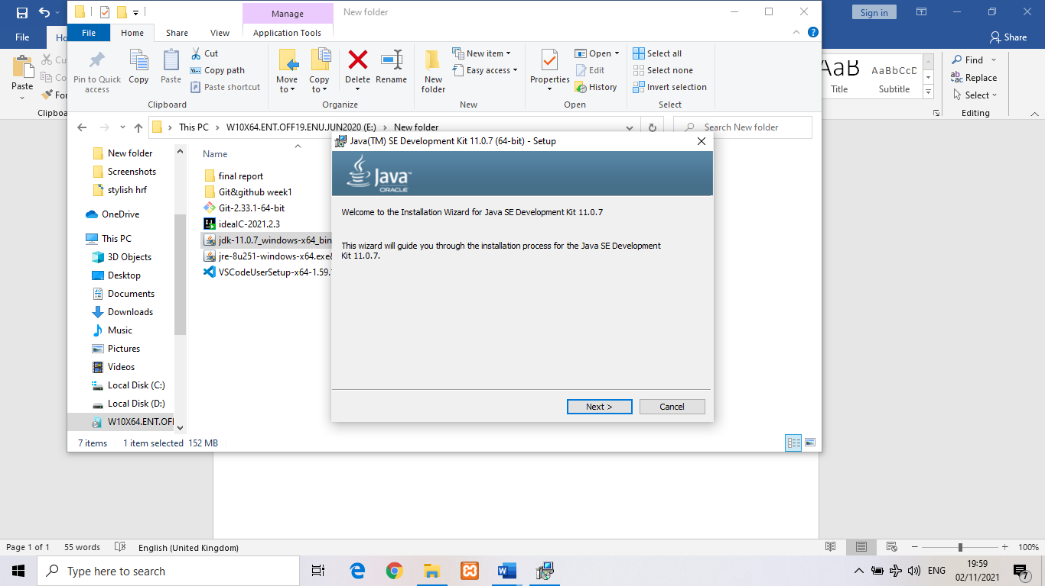

In this section the file of java will guide user on how to install JAVA. In this section you click next to go in next step.

1. In this section user select the path of jdk in order to install JAVA in computer.

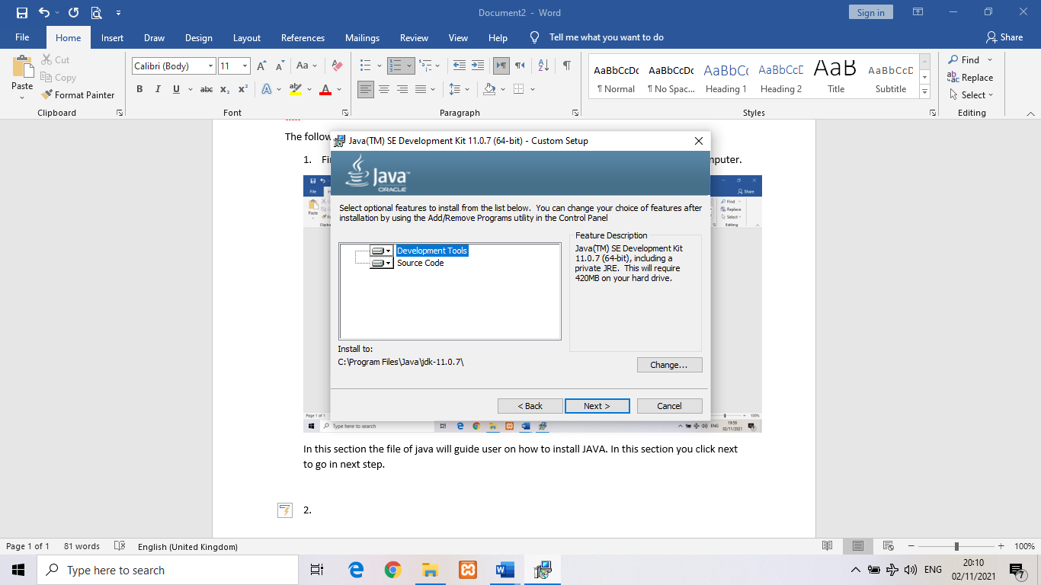

1. After making the installation, click ok.

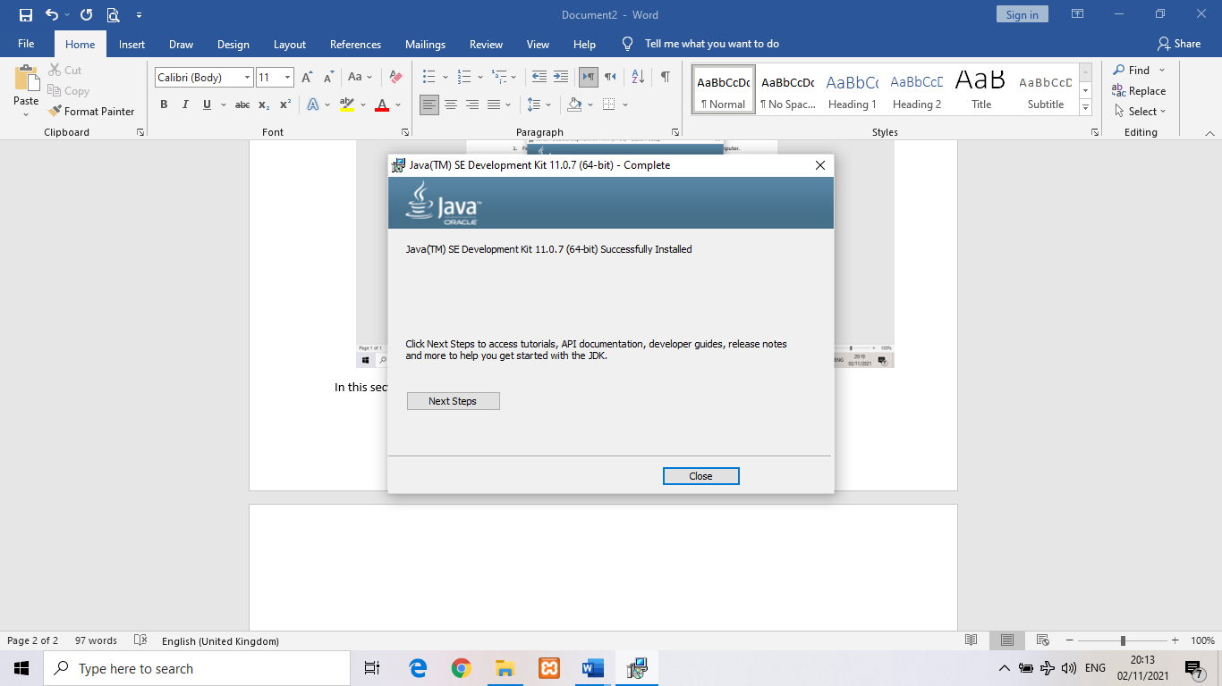

After making the installation it has must to have path variable. The following are the step to path the variable

1. After the installation you right click in this pc icon and select in property

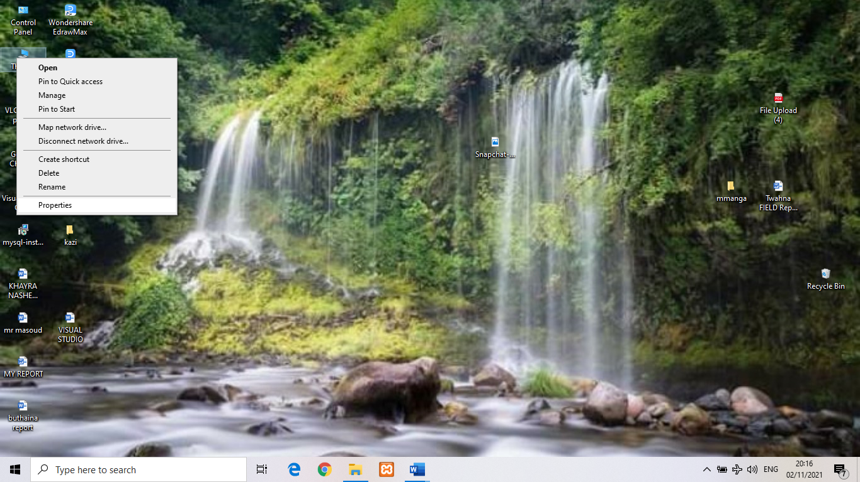

1. Click in advance system setting

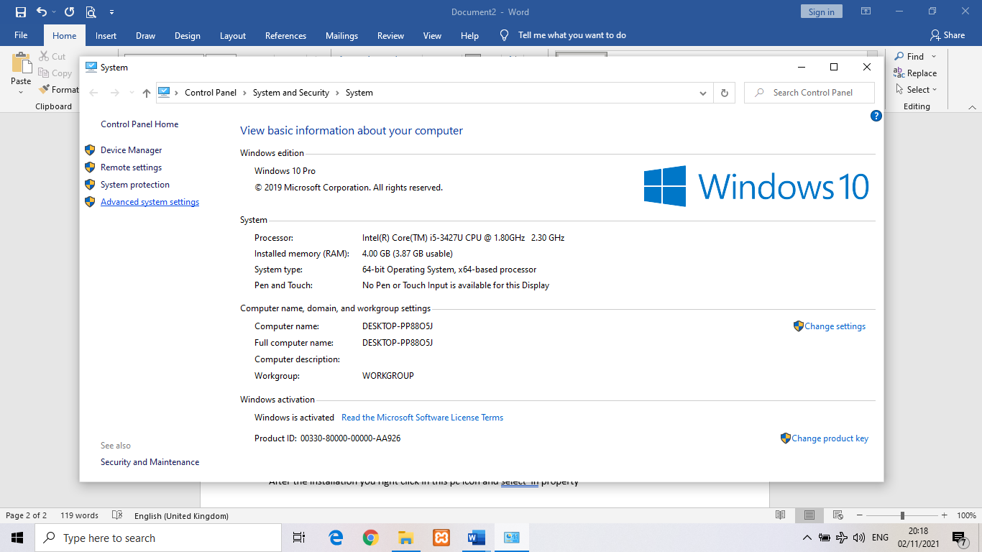

1. Click on environment variables

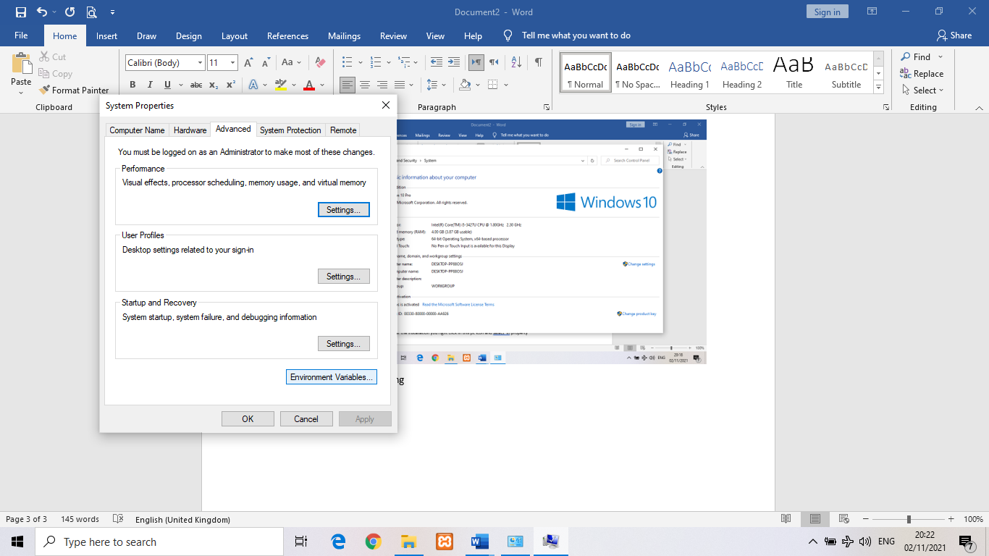

1. Click new button

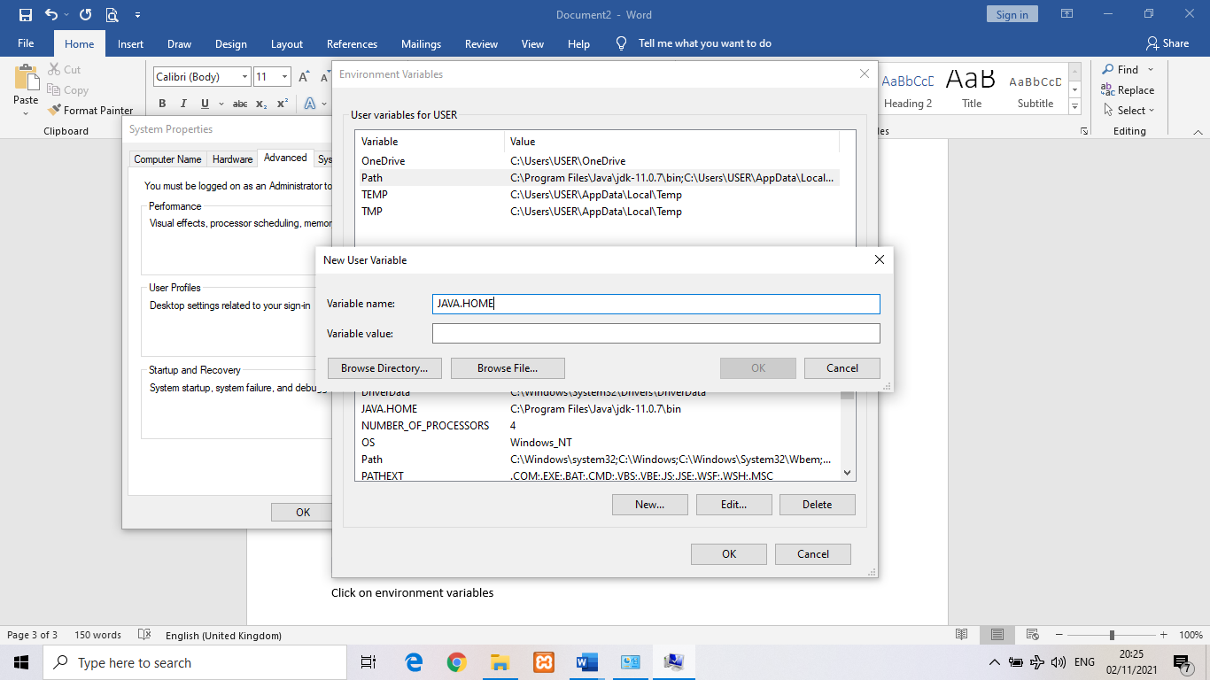

1. And copy the path of bin folder that has install jdk in local disk c

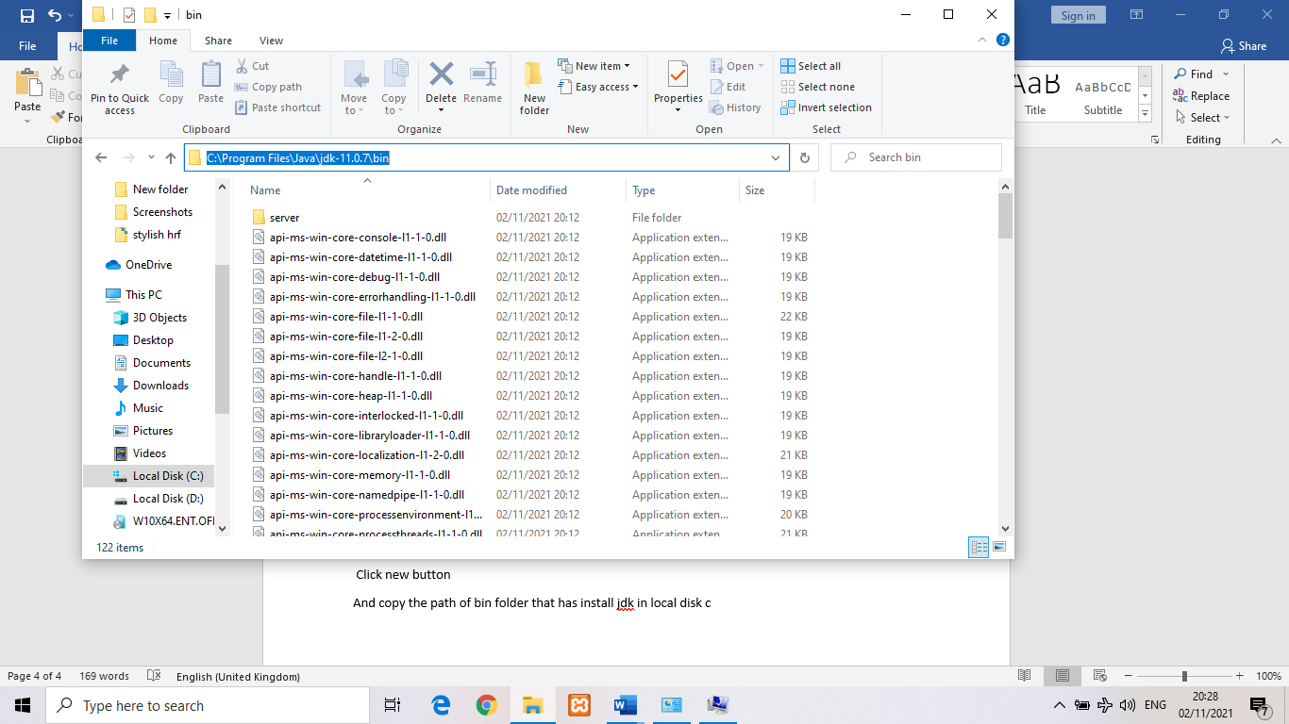

1. Inorder to make sure your installation is successful you go to cmd and wright javac. If your screen appear like this, java is already installed in your computer.

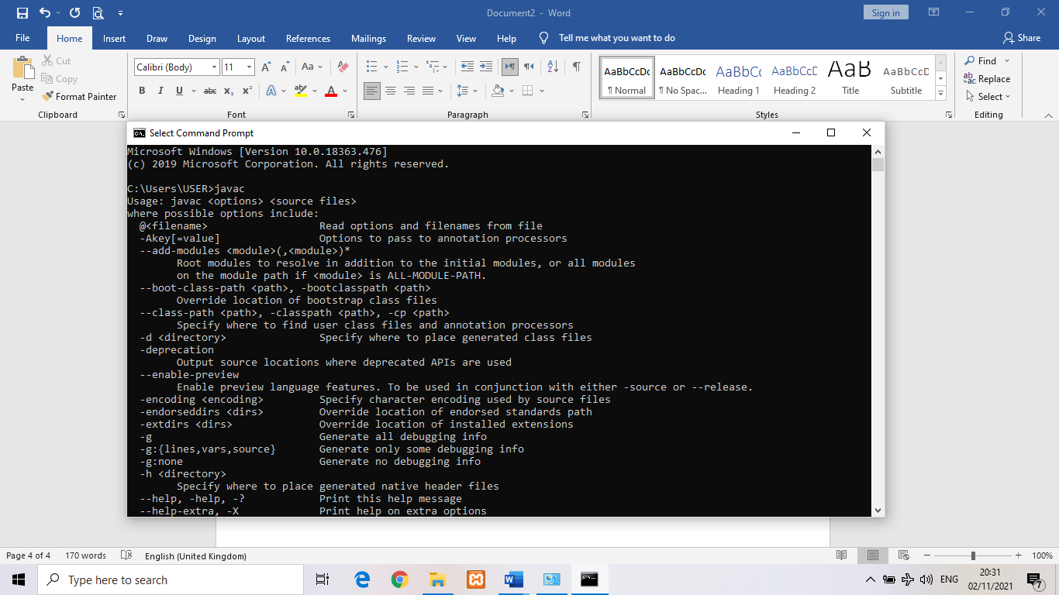

In order to make sure your installation is successful you go to cmd and write javac. If your screen appear like this, java is already installed in your computer.